Ison’s Nursery & Vineyard
PO Box 190, 6855 Newnan Road, Brooks, GA 30205 (770) 599-6970 www.isons.com email: ison@isons.com
________________________________________________________________________________________________
Warranty Claim
Our warranty applies to plants that were ordered and planted between November 1, 2023, and April 30, 2024 and planted in the appropriate USDA Zones.
If your plants or trees do not leaf-out we must be notified in writing by July 1st, 2024, following planting and provided that the plants were not injured by improper use of chemicals, fertilizers, fumigation, buyer’s negligence, or weather. Claims after July 1st will not be accepted.
If you suspect that your tree or plant has not survived, we require photo verification, including evidence that you have performed a “scratch test”. A photo is required for each plant being reported.
Email the pictures to us at ison@isons.com.
Please include the order number if you know it plus your name, address and phone number.
We will issue a “one-time” credit to your account equaling the purchase price of the plant reported. This credit is good for twelve months from the date it is issued and can be used for anything of your choosing. To redeem your credit please place your order by phone. (770) 599-6970.
We will begin shipping muscadine vines in late November, Berry Plants and other grapevines in December. Fruit and nut trees in January.
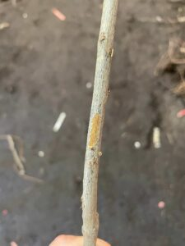
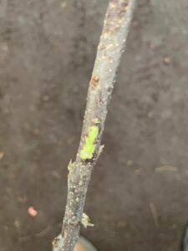
** Scratch Test: To see if the plant is alive use your fingernail or a knife and scratch the plant about 1/2 down the trunk – if it is green underneath the outer layer of bark – the plant is still alive & should leaf out – continue to fertilize and water them. If the plant is brown or black beneath the outer layer of bark this indicates that the tree has failed to live.
Green tissue is visible underneath the outer layer of bark.
This plant is alive.
There is no green tissue visible underneath the outer bark.
This plant is not alive.

Order #: _______________ Name order was placed in: _________________________________
Address: ______________________________________________________________________
Phone #: __________________
Quantity __________ Name of plant ____________________________________________________
Quantity __________ Name of plant ____________________________________________________
Quantity __________ Name of plant ____________________________________________________
Quantity __________ Name of plant ____________________________________________________

